

Computer Systems Fundamentals

(H175 34)

Outcome 3, Task1

“Install Microsoft Windows 7, Professional edition”

An electronic record of your activities

Your name: Chris Dworczyk

Date: 08/03/2017

Your class: HNC3 group

Preliminaries:

Logon to your workstation with hccomp credentials

Navigate to the

C:\ Program Files\Microsoft Learning\CompSysFun\Outcome3\HNC3 folder

Launch the “HNC3_Windows7” Virtual PC image

Click on the Settings button within the Virtual PC Console and ensure the

‘Close’ setting as shown:

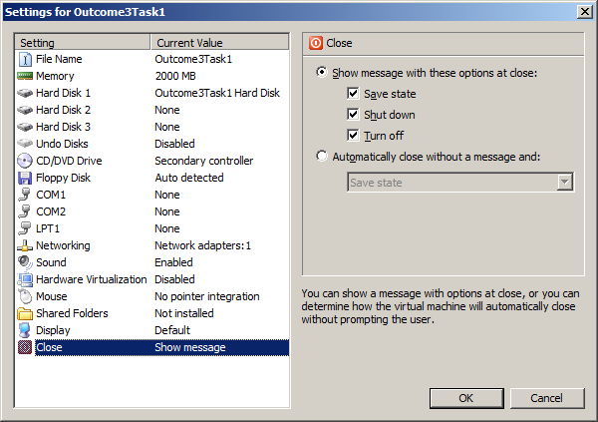

Insert the Windows 7 installation disk into the DVD drive, having made sure that the CD | Use Physical Drive Virtual PC menu option has been selected

Boot from the Windows 7 installation DVD and describe in detail in the response area below, the steps you take to perform a clean install of Microsoft Windows 7, Professional edition, Service Pack 1

1.Select the language to install the windows with and press next

2.Read the terms of agreements and check the box to continue.

3.Select a drive for windows to be installed on and press next

4.Wait as windows is being installed on the computer

5.Chose the name of the PC and press next

6.Enter a password for the PC and press next

7.Finally chose a network type for your current local connection and press next.

Windows should now do its final set up and display the desktop.

Take a screenshot of the installed O.S. desktop; be sure to use the start button to show your account name

When completed, save this document and provide your lecturer with an electronic copy together with any separate screenshots etc.

And finally, you will now be required to demonstrate the working operating system to your lecturer